Spirituality Serenity Sustainability
Finca La Magdalena
Spiritual Retreat
 | 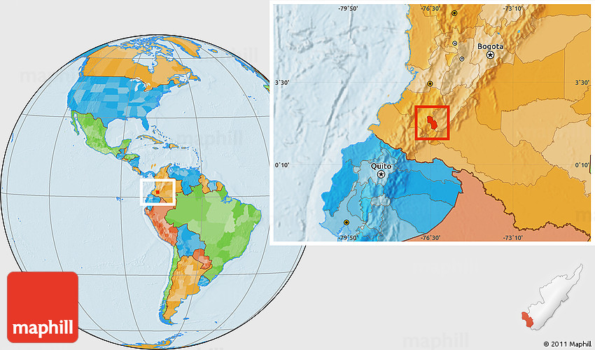
San Agustin, Huila, Colombia, South America |  | Contact Us

  Living in harmony
  is a difficult balance to achieve. Our daily lives interfere constantly with our goal to live harmoniously
  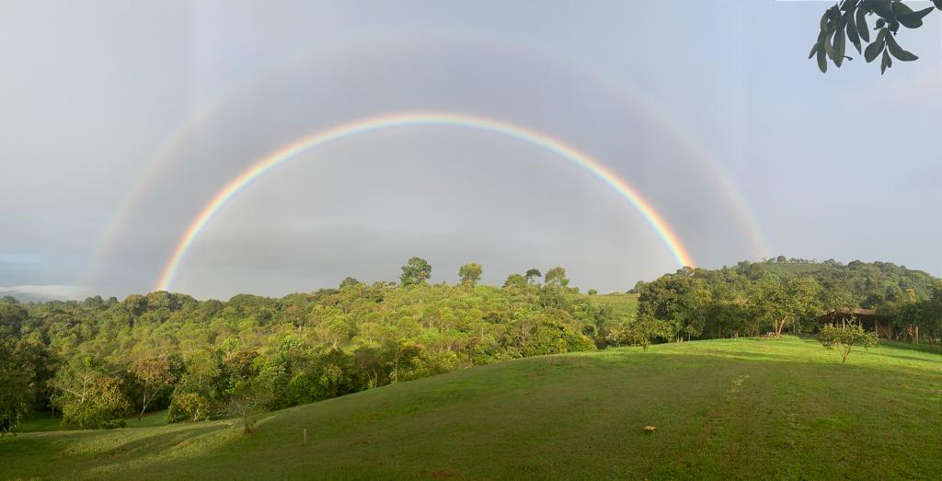

  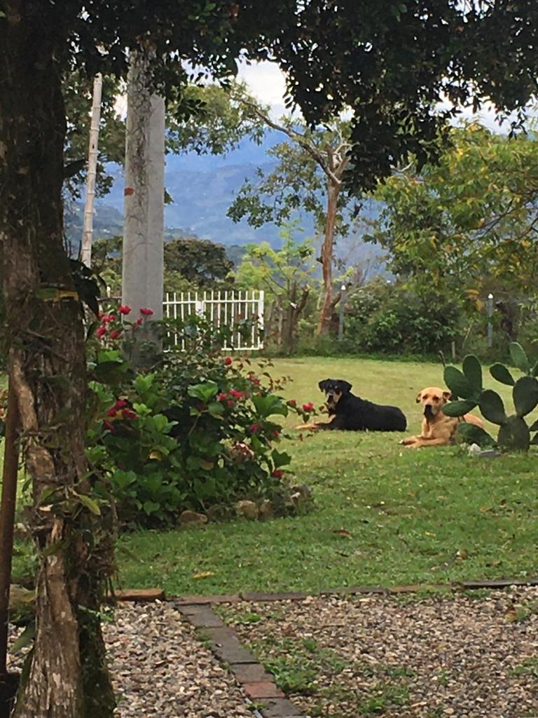
  What does it mean to live in harmony?
  When the four elements of life: body, mind, spiritual connection and source are in sync, you live in harmony
  What are the signs that you are not living in harmony?
  Your body may have fallen into disease, or your mind into a vicious cycle, you may feel spiritually lost, disconnected, or your are not getting clear messages from your source

  What is Finca La Magdalena?
  It’s a harmonious place located at the foot of an ancestral sacred mountain, near the Unesco World Heritage town of San Agustin in Huila, Colombia . Located on a 37 acre plot of land, Finca La Magdalena was designed using the principles of “Natural Geometry” sustainability, conservation, and restoration
  What to expect from a visit?
  Our unique space is serene, with spiritual portals, sustainable designs, beautiful gardens and flowers. There is also water falls, woods, splendid views and dozens of birds and butterfly species. It is as close to paradise as it gets
  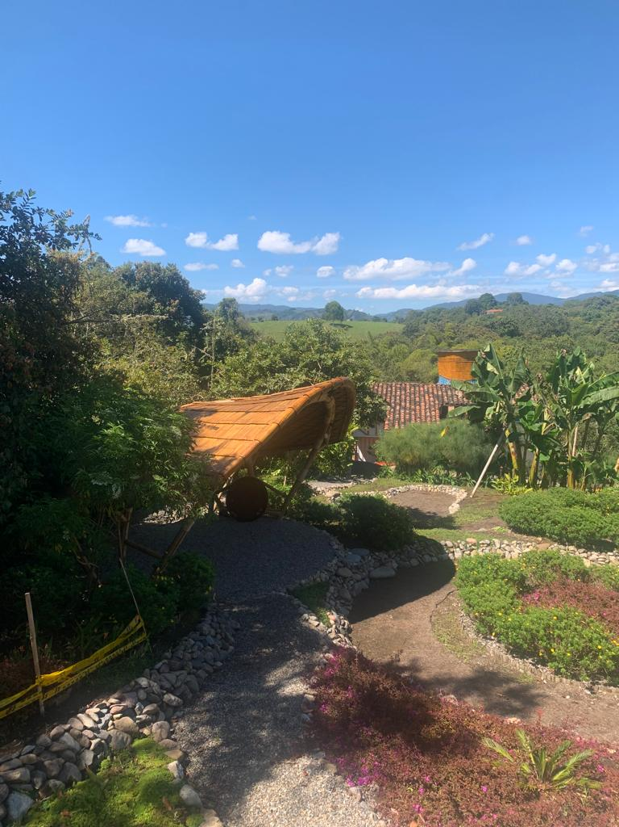

  Find balance in your life!
  Book a visit with spiritual guidance
   | Wheel chair accessible
   | Guides tours

 | 
Upcoming Events

  Have a cup of
  the best coffee in the
  world
  with your
  
  November 25, 2023
  Afternoon Tea
  A traditional English meal
  
  Book in advance

Finca la Magdalena Vereda la Chaquira, San Agustin, Huila, Colombia | sales@fincalamagdalena.com

